**iSurpass beehive configuration**

## Login

<http://<server>:8181/> admin/1

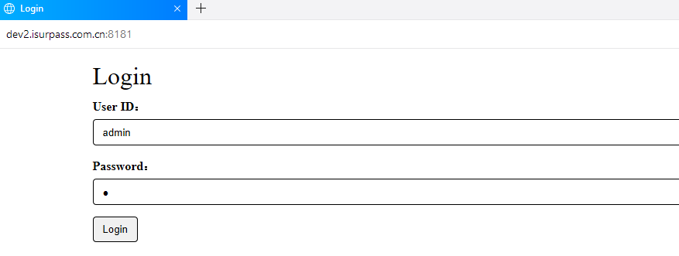

## **Create New Bee**

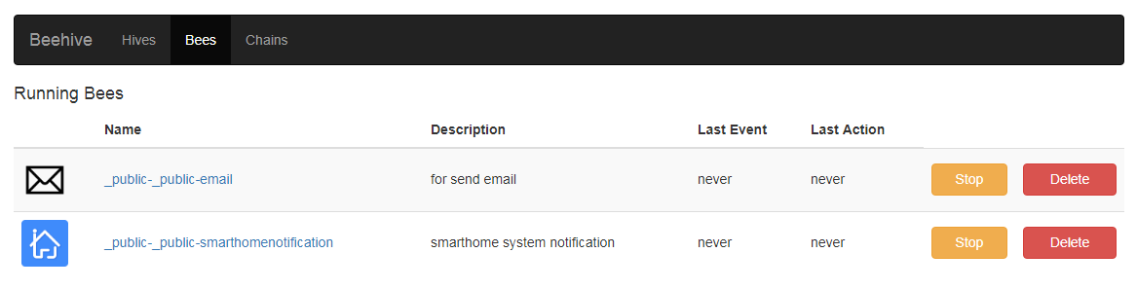

### 2.1 Email

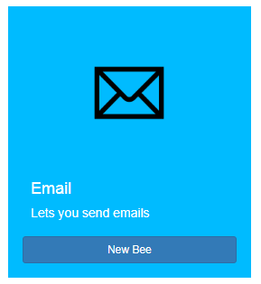

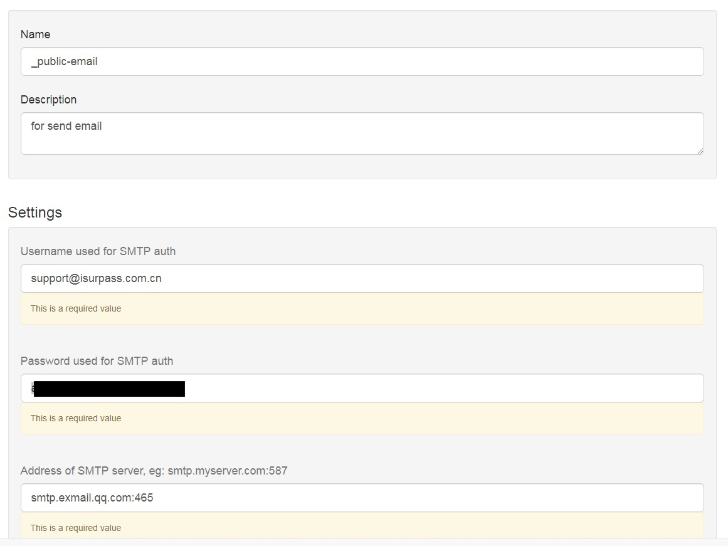

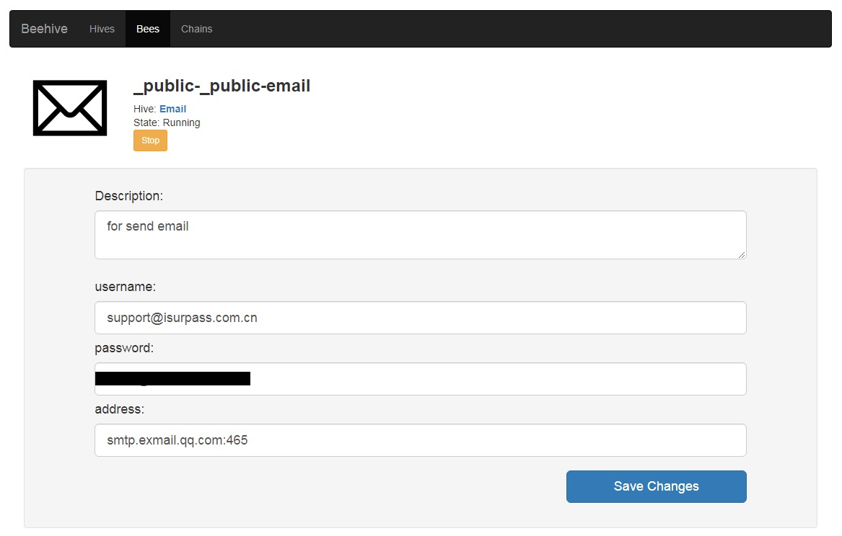

### **2.2 SmarthomeNotification**

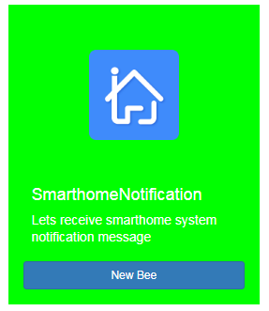

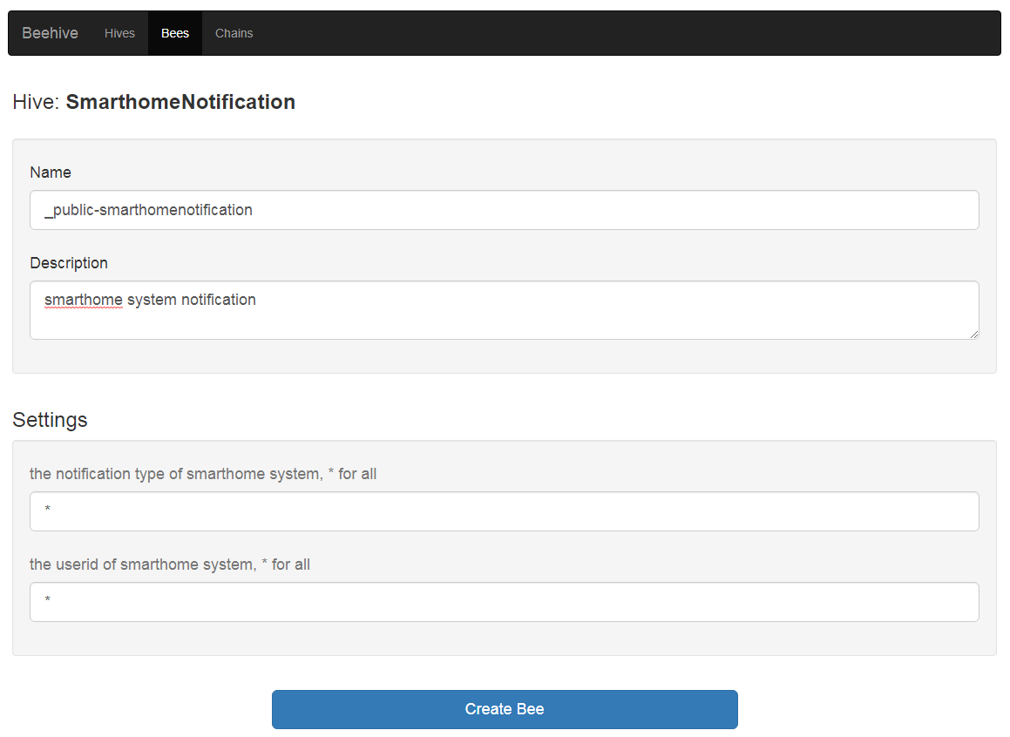

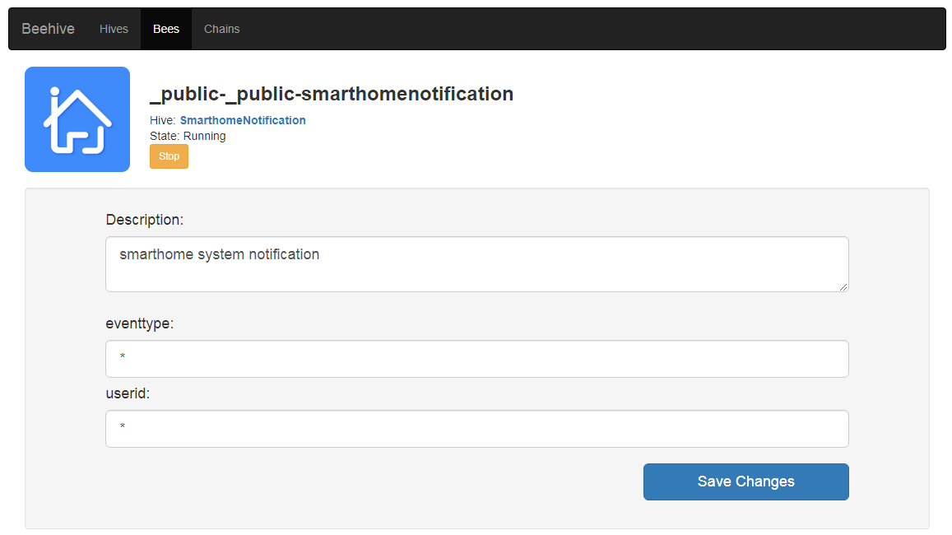

## **Create New Chain**

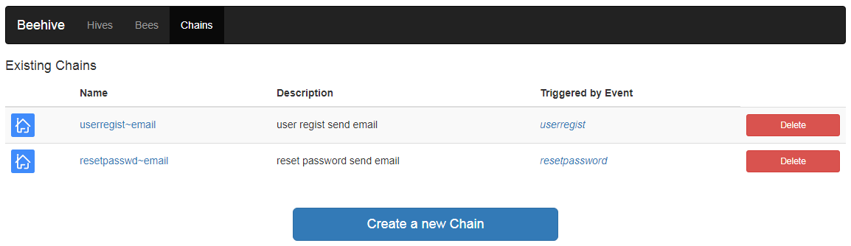

### **3.1 user register**

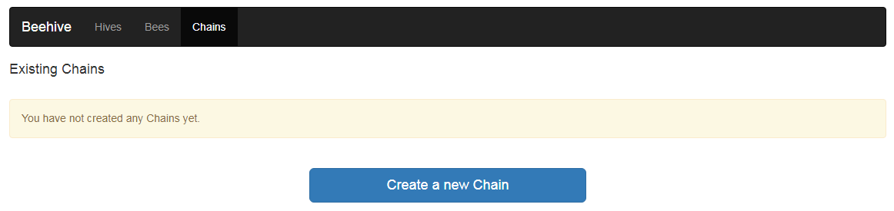

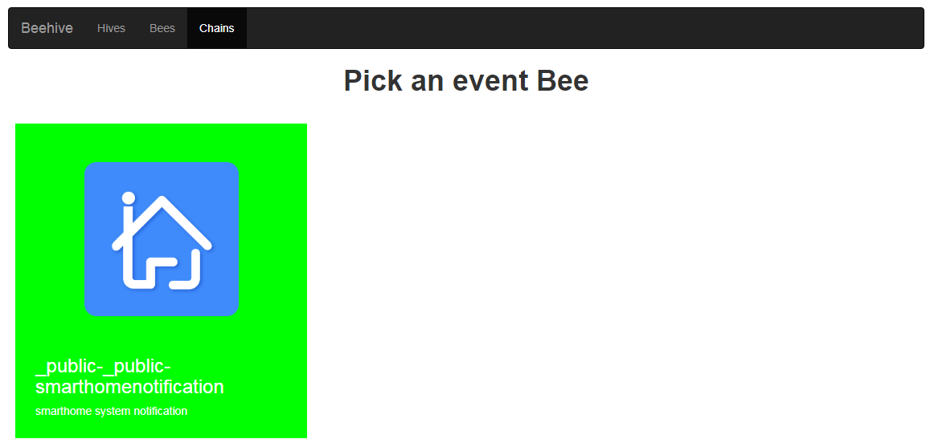

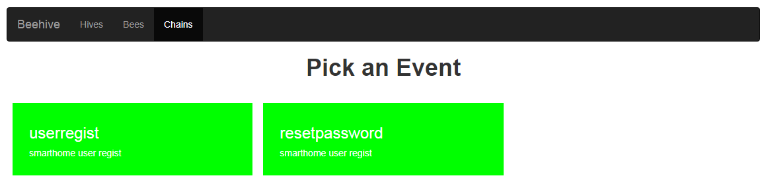

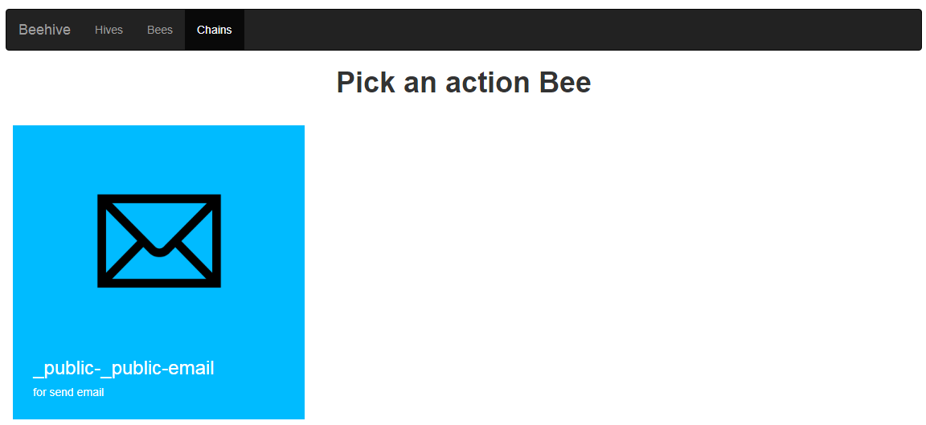

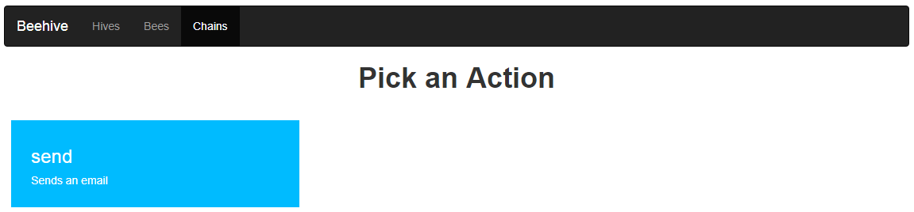

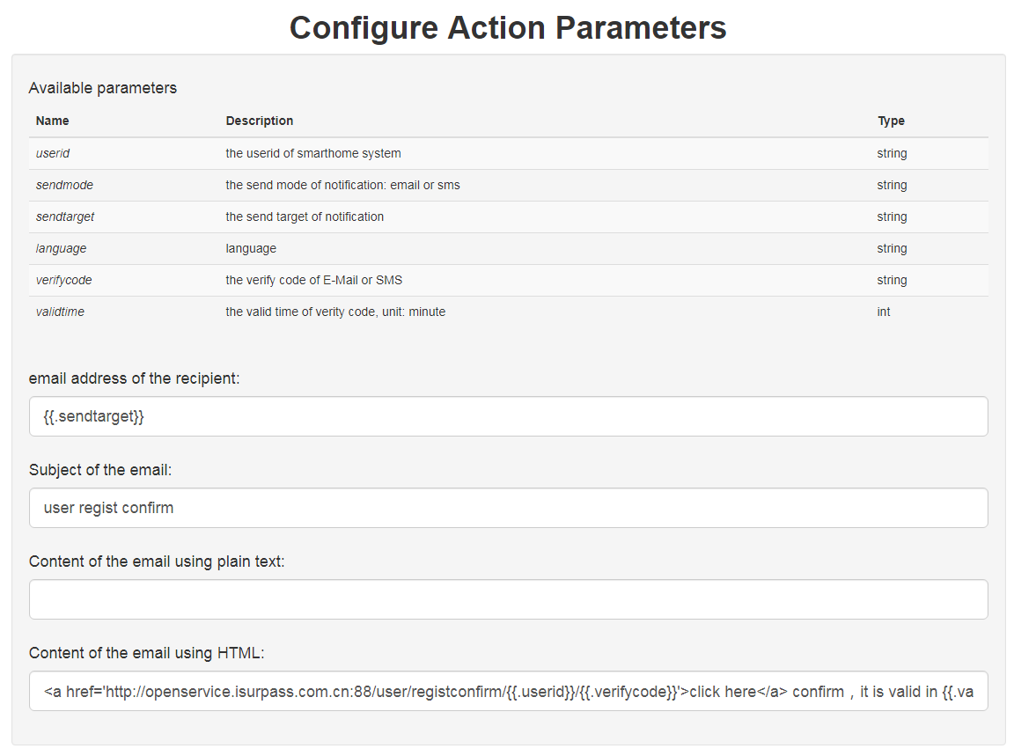

Notes:

Email address of the recipient: {{.sendtarget}}

Subject of the email: user regist confirm

Content of the email using HTML: <a href='http://**<server>**:88/user/registconfirm/{{.userid}}/{{.verifycode}}'>click here</a> confirm，it is valid in {{.validtime}} minutes！

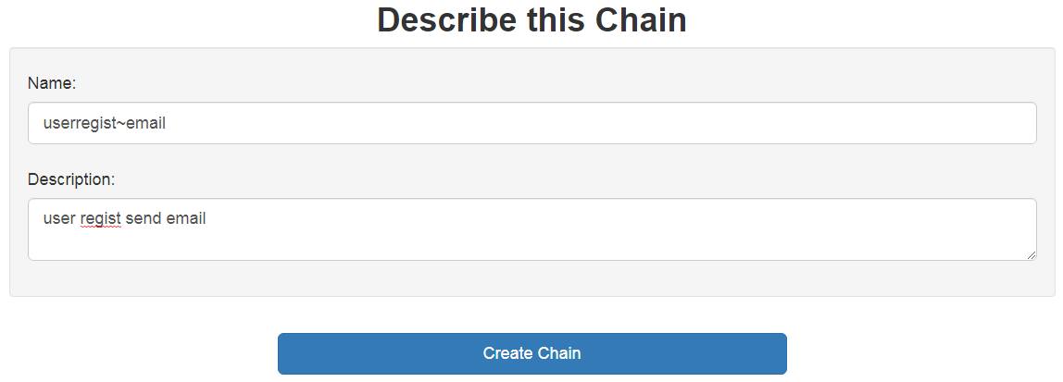

### **3.2 reset password**

**The process is the same as creating user register Chain.**

Notes:

Email address of the recipient: {{.sendtarget}}

Subject of the email: user reset password confirm

Content of the email using HTML: <a href='http://**<server>**:88/user/resetpwdconfirm/{{.userid}}/{{.verifycode}}'>click here</a> confirm reset your password，it is valid in {{.validtime}} minutes！